T.SATHEESH

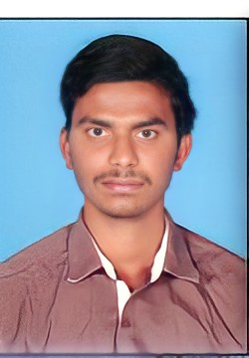

Mail: [thunikisatheesh@gmail.com](mailto:thunikisatheesh@gmail.com)

Contact: +91-9908843736

**Objective Career:**

To work in a challenging and stimulating environment with opportunity to use my experience and to enrich my knowledge and enhance my experience. To contribute towards the achievement of organizational objective by applying my professional skills.

**Educational Qualifications:**

* Bachelor of Science (Computer science) with aggregate of 61%, Ramakrishna Degree College (**2016**)
* Class XII (Intermediate). with aggregate of 75%, Sri Vidhyathi Jr. College korutla (**2013**).
* S.S.C., with the aggregate of 86% Goutham High School korutla (**2011**).

**Professional Experience:**

**Got more than 3.4 years of experience for Digital Marketing Industry.**

Company:**FRONTLINE TECHNOLOGIES LTD**

Designation: **Senior Analyst**

Duration:**MARCH 2018 to JUNE 2021**

Worked for Content Management

* Worked on Oscar Tool
* Used to Approve and Disapprove Google Ads
* Social Media Optimization (Face book marketing)
* Ad Words Management
* Undertake activities such as Keyword Research
* Designing tightly themed Campaigns and Ad Groups
* Keeping keyword quality score high & Lowering CPC by constantly monitoring performance of keywords
* Creating, Compelling Ad copy, using Google Ad Words editor to make bulk changes, Keyword Match types for higher exact match clicks, adding Negative keywords, keyword research etc and optimizing for good performance.
* Analyze detailed data including Avg. CPC, Impressions, CTR and Conversions.
* Looking at the Impression share reports and analyzing them for better results.

**Technical Proficiency:**

* HTML
* CSS
* Google Ad words
* Digital Marketing
* Pay Per Click
* Search Engine Marketing
* Software: MS-Office (Excel, Word, PowerPoint)

**Personal Traits:**

* Sincerity.
* Good in interpersonal skills.
* Believe in teamwork.

**Language Proficiency:**

* English, Hindi, Telugu(Mother Tongue)

**Hobbies:**

* Playing cricket
* Reading books
* Listening music
* Love to Travel

**Personal Profile:**

Name: T. Satheesh

Father’s Name: T.Chinna sailu

Sex: Male

Nationality: Indian

Marital status:Married

**Place**:

**Date : (**T.SATHEESH**)**